Data Processing Unit Board

Testing Guide

Version | Update Date | Author | Memo
V0.0.1 | November 5, 2025 | Anonymous | Initial Version.

CONTENTS

Table of Contents
1. Hardware Preparation 3
2. Hardware Connection 3
2.1 Connect DPU to DC Power Supply 3
2.2 Set Over Current Threshold and Power On 4
3. Power Rails Ripple Voltage Test 4
3.1 P3V3 Ripple Voltage 4
3.2 P2V8 Ripple Voltage 5
3.3 P1V8 Ripple Voltage 5
3.4 P1V0 Ripple Voltage 6
3.5 P1V5 Ripple Voltage 6
4. Oscillator Frequency Test 8
4.1 FPGA External Clock – 25.0MHz 8
4.2 OV5640 Clock – 24.0MHz 8
4.3 W5500 Clock – 25.0MHz 8

1. Hardware Preparation
This guide demonstrates how to test the DPU board in comprehensive. Although this board is designed to get power supply from PoE (Power Over Ethernet), it also can be powered from lab power supply. Before testing, please make sure all components below are ready.

No. | Components Name | Memo
1 | DuPont Wire | Connect DPU Board to Lab Power Supply
2 | DPU Board | One piece of DPU Board
3 | Ultrasonic Sensor PreAMP Board | One piece of Ultrasonic Sensor PreAMP Board
4 | Oscilloscope | Check waveform.
5 | Oscilloscope Probe | Probe x10
6 | Digital Multi-meter | Flue Multi-meter
7 | Lab DC Power Supply | 5V Voltage Source
8 | PoE Injector | Supports both Alternative A and Alternative B

2. Hardware Connection

2.1 Connect DPU to DC Power Supply
Connect DPU board to Lab DC Power Supply with DuPont wires. Ensure the correct pinout before connecting. The left pin is 5V, the middle one is floating, the right is GND. Warning, no polarity protection circuit on board due to PCB size.

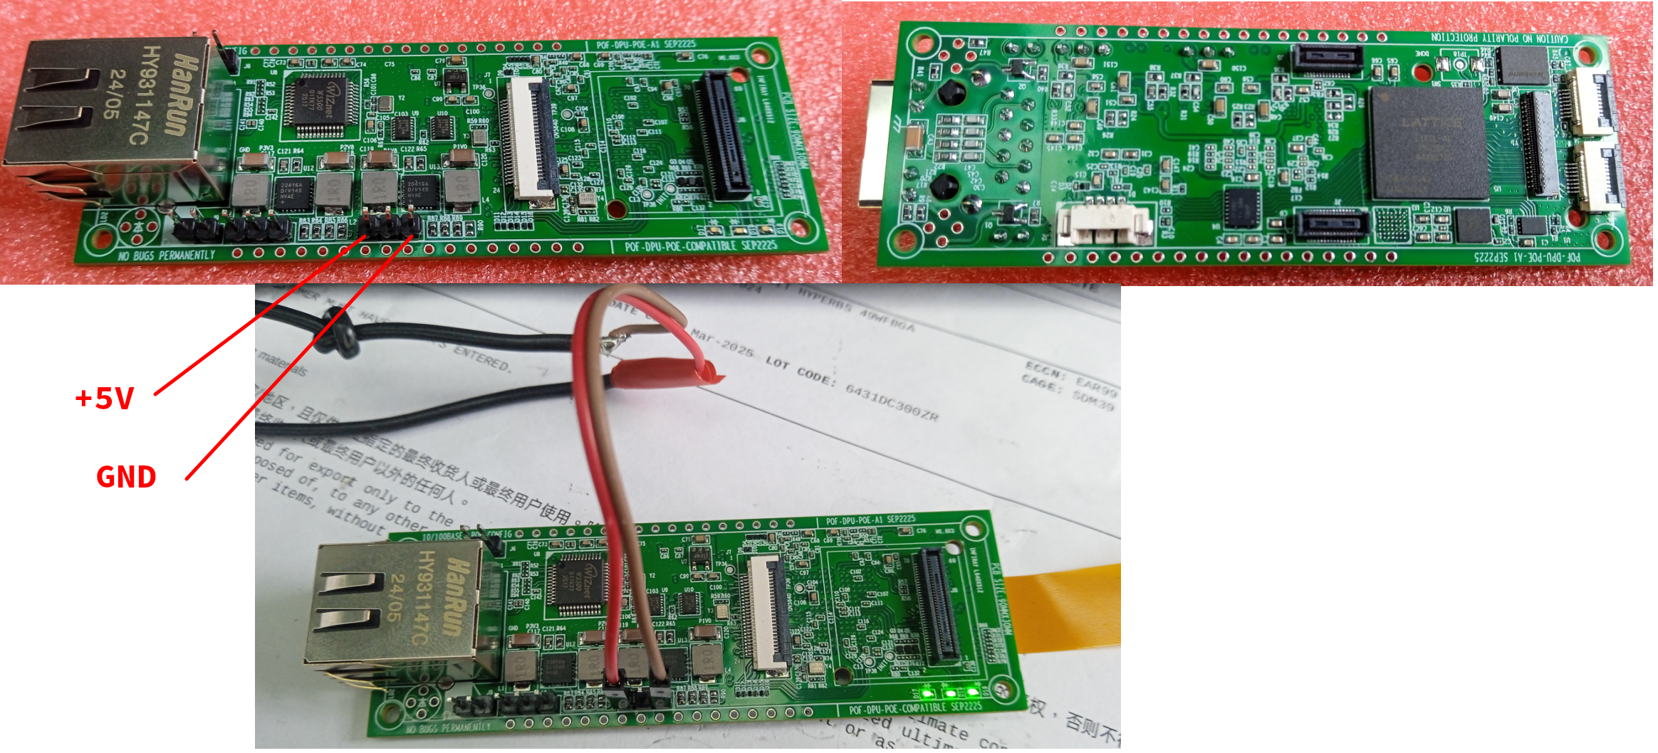

2.2 Set Over Current Threshold and Power On
At the 1st time, set a lower over current threshold in order to cut off power supply immediately in case of short-circuit. Experience shows 200mA is appropriate. The current consumption accelerates as FPGA logic expands. If over current occurs, troubleshoot the hardware carefully.

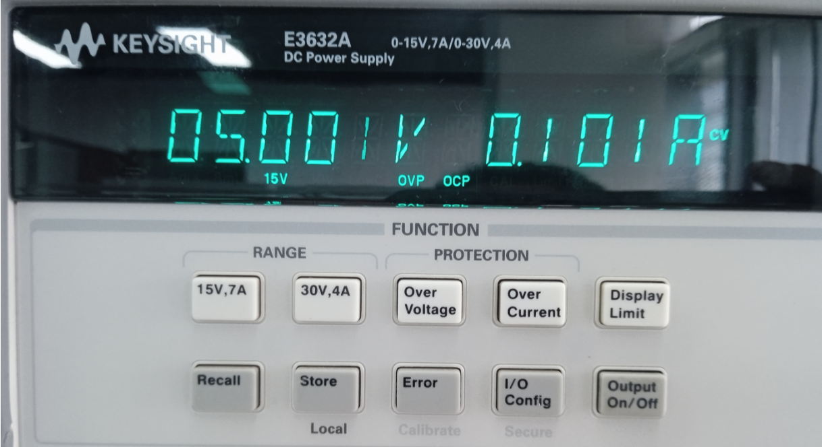

3. Power Rails Ripple Voltage Test

3.1 P3V3 Ripple Voltage
Measure P3V3 power rail ripple voltage at the point described below. Avoid long ground loops when using an oscilloscope probe. Vpp<=22.74mV

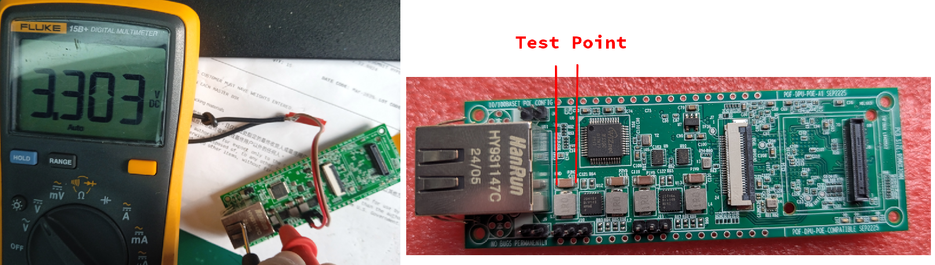

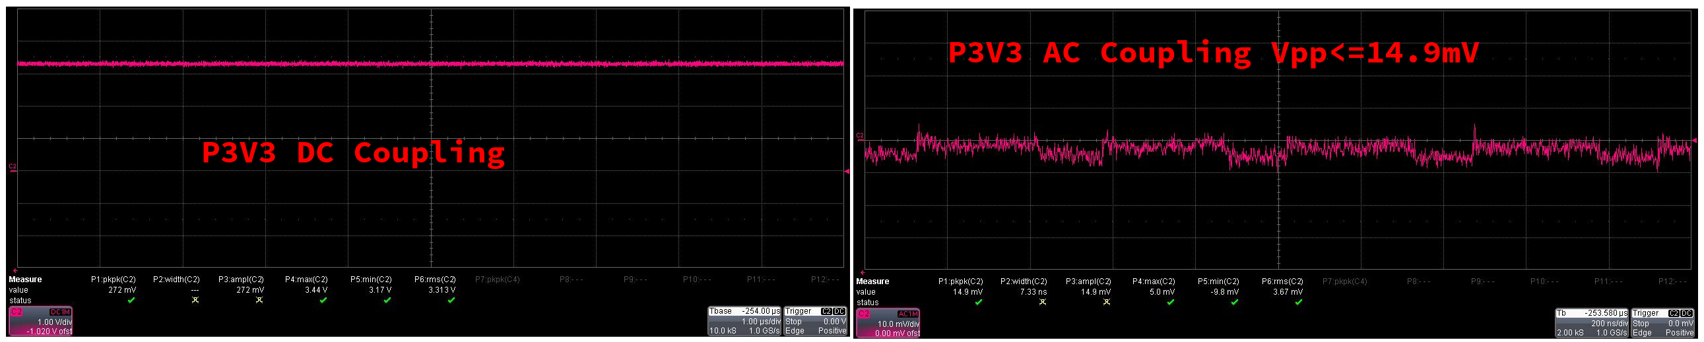

3.2 P2V8 Ripple Voltage

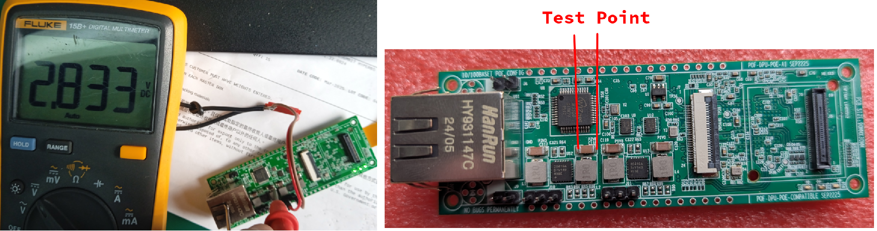
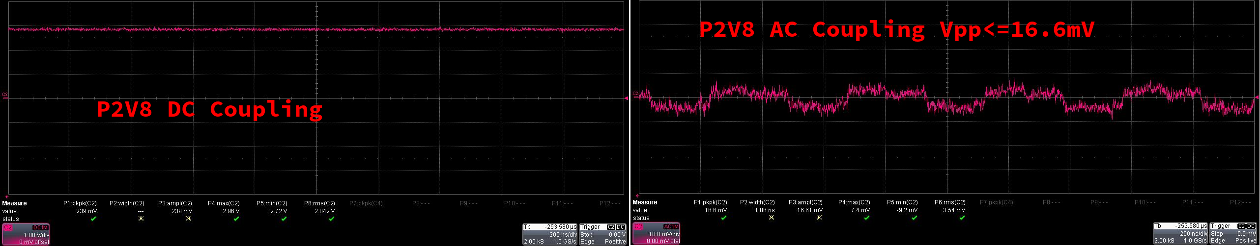

3.3 P1V8 Ripple Voltage
P1V8 supplies I/O drive circuit and auxiliary parts. It’s voltage tolerance is between 1.746 and 1.89V. Thus, 1.8V-1.746V=54mV. 1.89V-1.8V=90mV. Ensure the voltage ripple is less than 54mV.

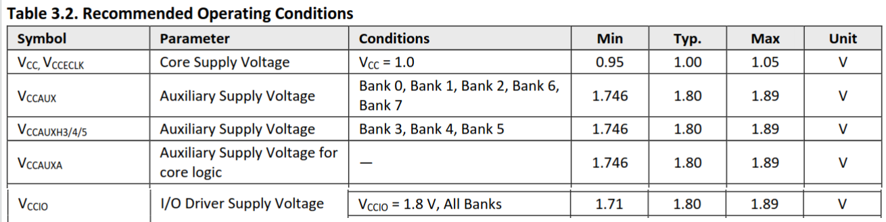

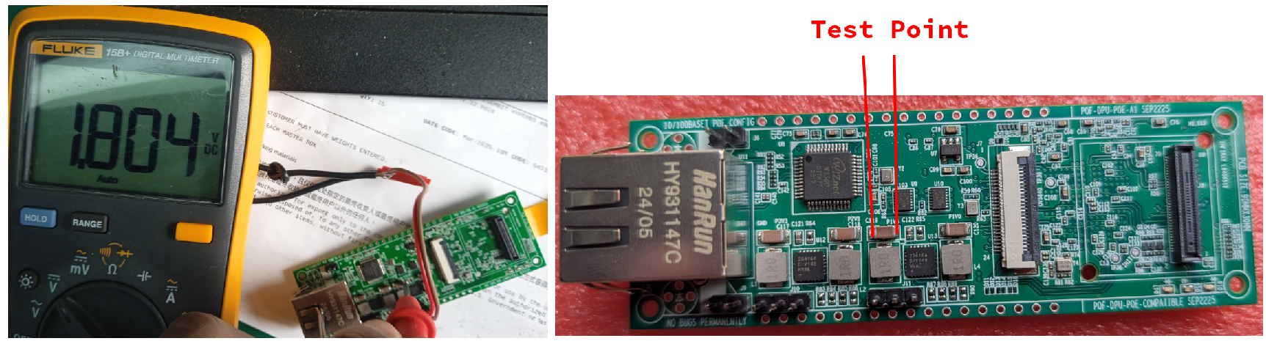
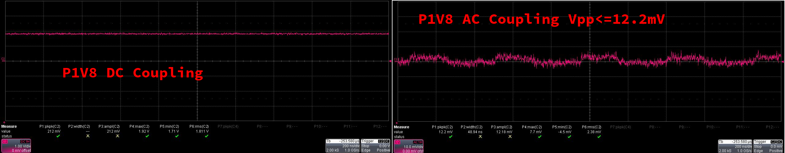

3.4 P1V0 Ripple Voltage
FPGA core works at a low voltage of 1.0V. Its official manual shows the voltage tolerance is between 0.95V~1.05V, ensure the ripple voltage is less than 50 millivolt.

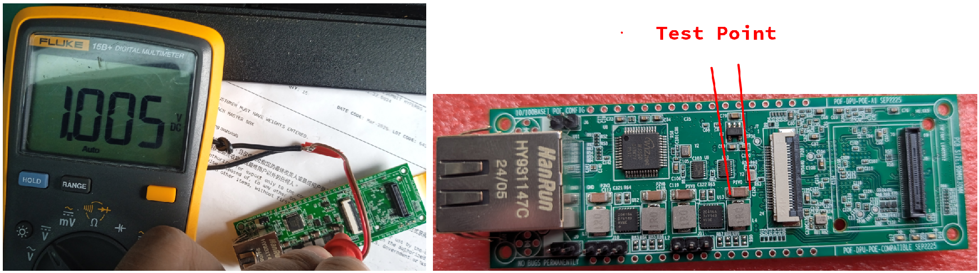
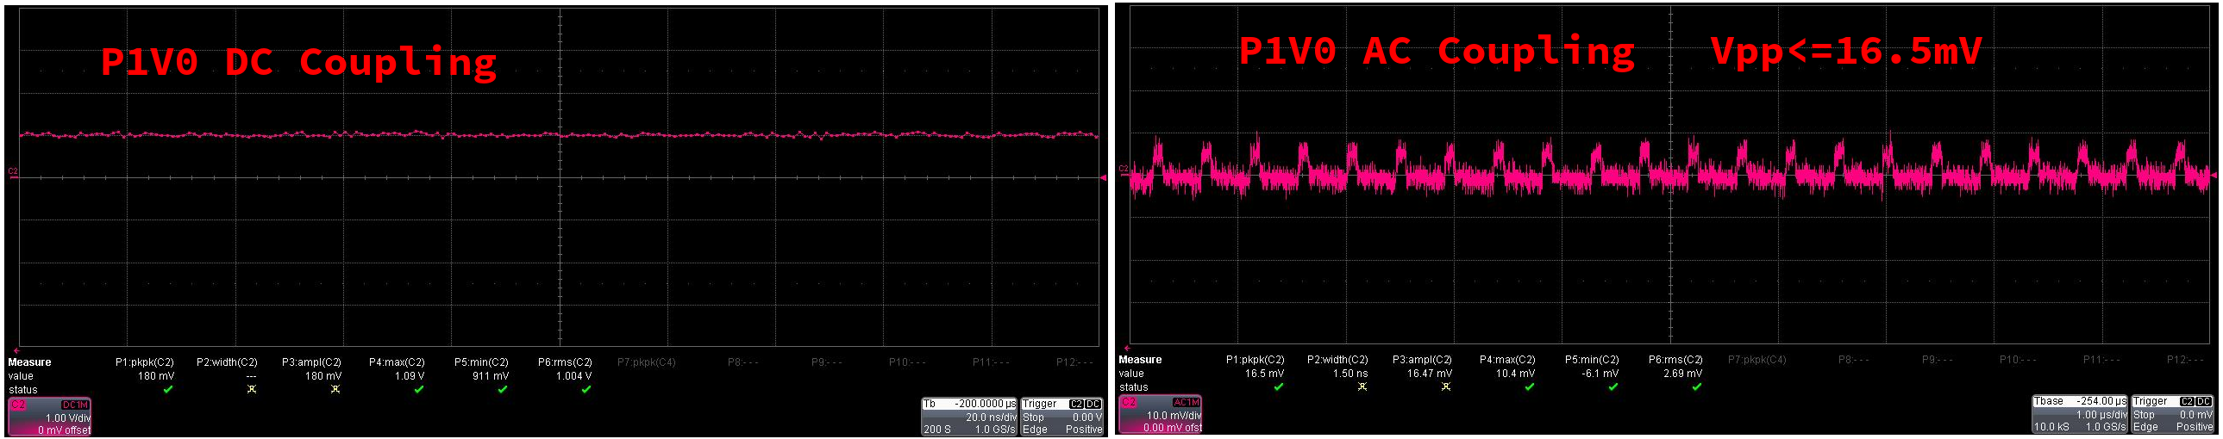

3.5 P1V5 Ripple Voltage
P1V5 power rail is mainly used for OV5640, so it’s placed near the DVP connector.
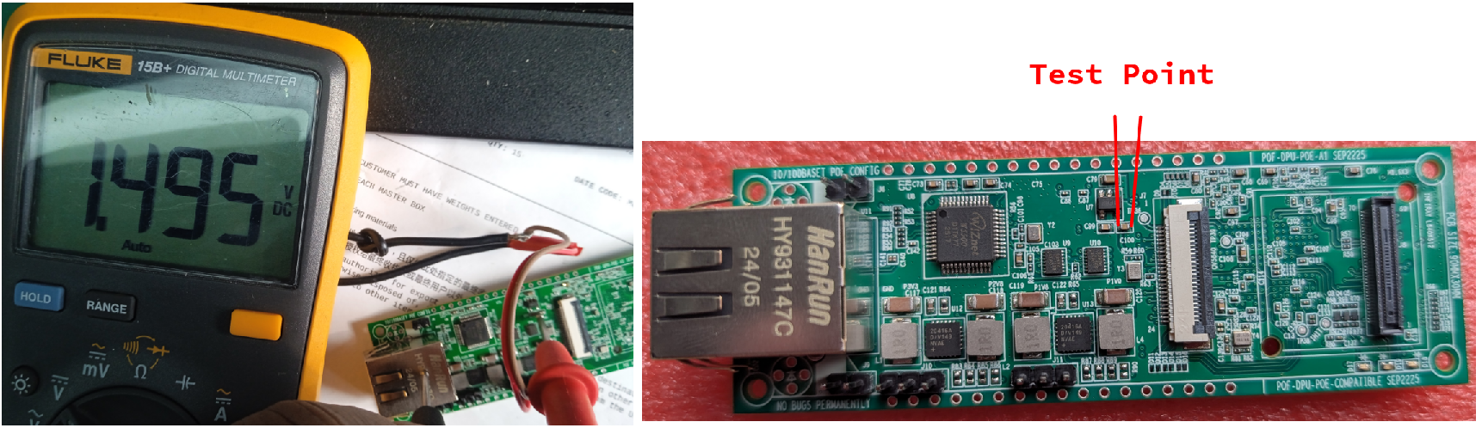
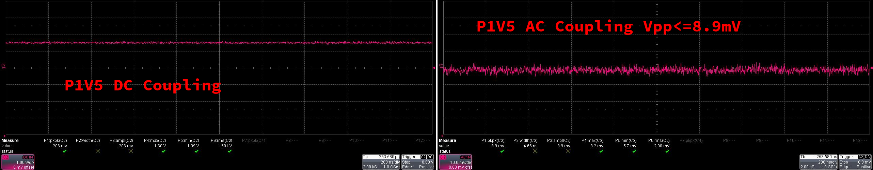

4. Oscillator Frequency Test

4.1 FPGA External Clock – 25.0MHz
Although LIFCL-40 has built-in clocks, an external oscillator of 25.0MHz is also soldered on board. Ensure the frequency is correct, and the amplitude is 1.8Vpp.
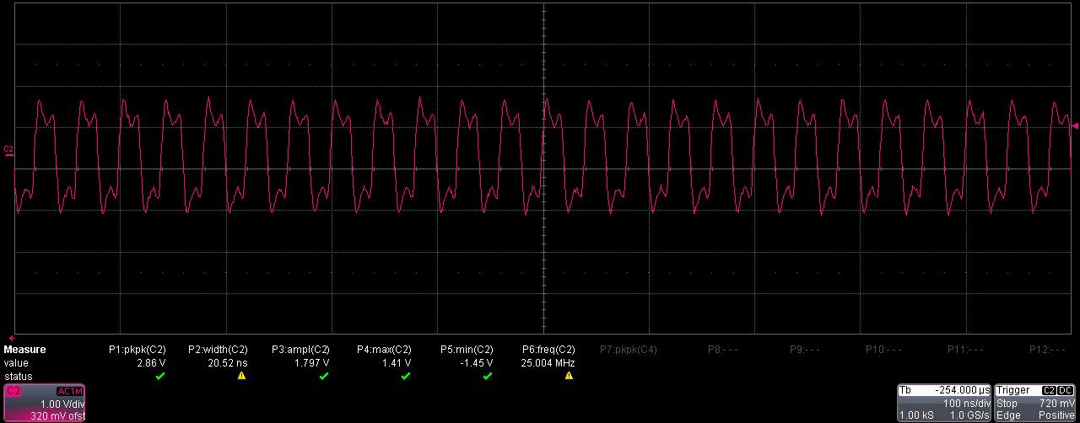

4.2 OV5640 Clock – 24.0MHz
Visible Light Image Sensor OV5640 uses an external oscillator of 24.0MHz, ensure the frequency is correct, and the amplitude is 1.8Vpp.
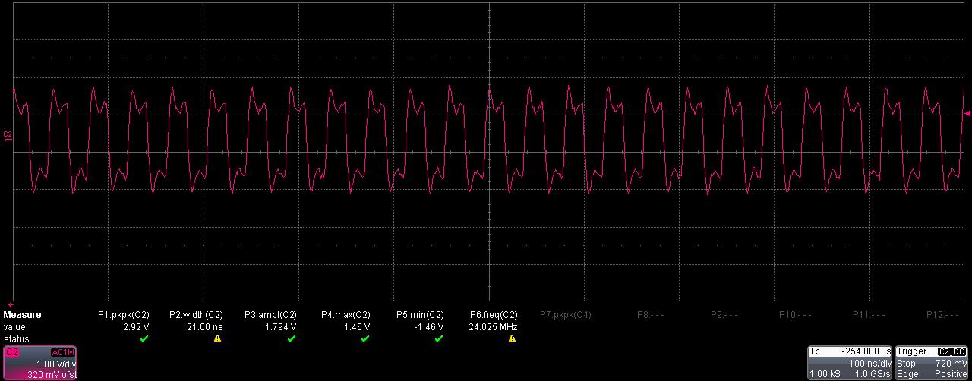

4.3 W5500 Clock – 25.0MHz
W5500 Ethernet Chip uses an external crystal of 25MHz, ensure the frequency is correct, and the amplitude is 1.8Vpp.
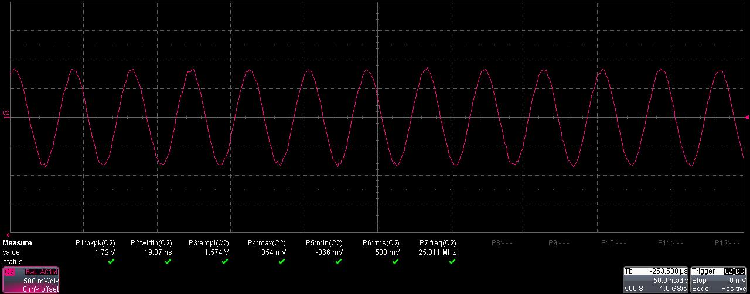

5. Network Cable Connection Test
At default, the two LEDs will be turned on and flash when plug network cable. But make sure the ETH_RST(Pin 37) is pulled to high to set W5500 in normal mode, pulled to low will force it enters RST mode. So please drive ETH_RST to HIGH in FPGA logic.
RJ45 has two built-in LEDs. The Linked LED is on when cable connects, the ACT LED flashes when W5500 receives network data frames even without configure data written in.

6. PoE Injector Test
Using a straight through cable to connect DPU board to PoE Injector or a network switcher. Poor quality network cable may cause error, the PD can’t get power supply from PSE. Copper wires are highly recommended. DPU uses 10/100 BASE-T RJ45 connector, only supports 10/100 BASE-T Power Over Ethernet standard. Both Alternative A and Alternative B are verified successfully. Alternative A uses the center tap of 1-2 pair and 3-6 pair. Alternative B uses the spare wires, 4-5 pair and 7-8 pair. PoE power supply module don’t care about the polarity because of a bridge rectifier used.

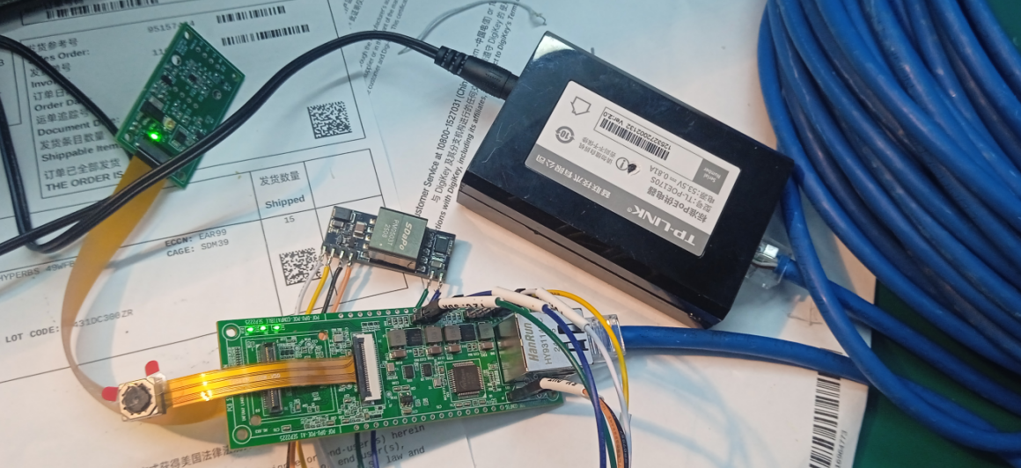
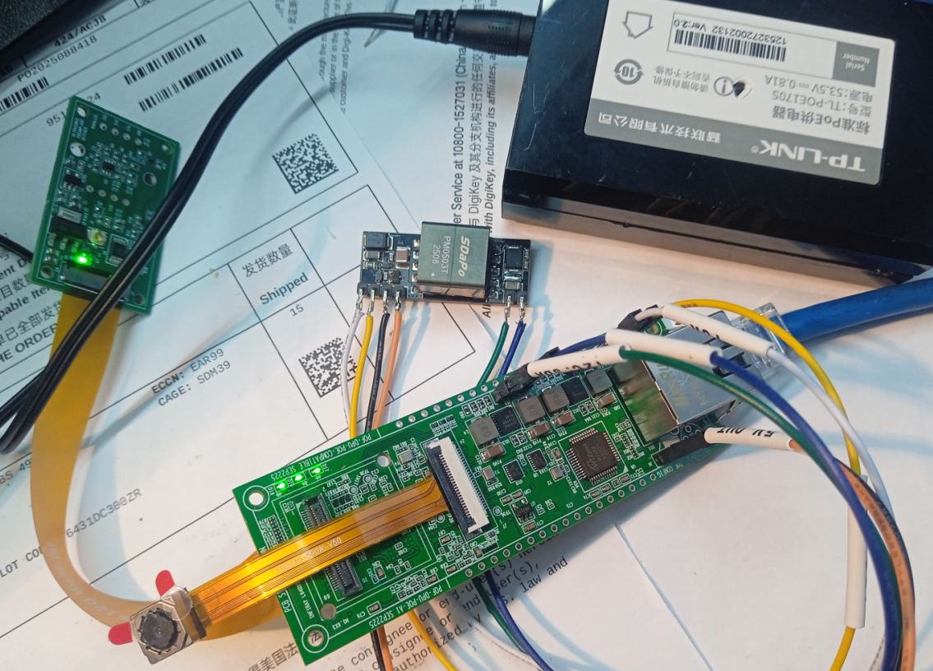

7. Entire Board Power Consumption
Peak current reaches to 0.3A when the infrared image sensor shutter works.
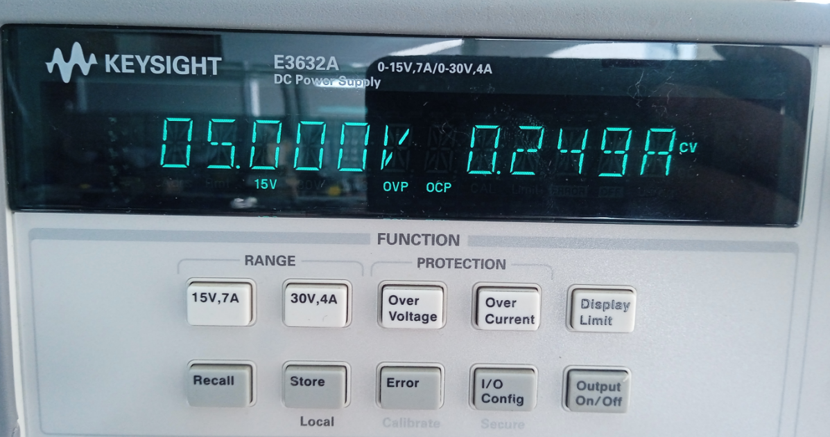

8.

